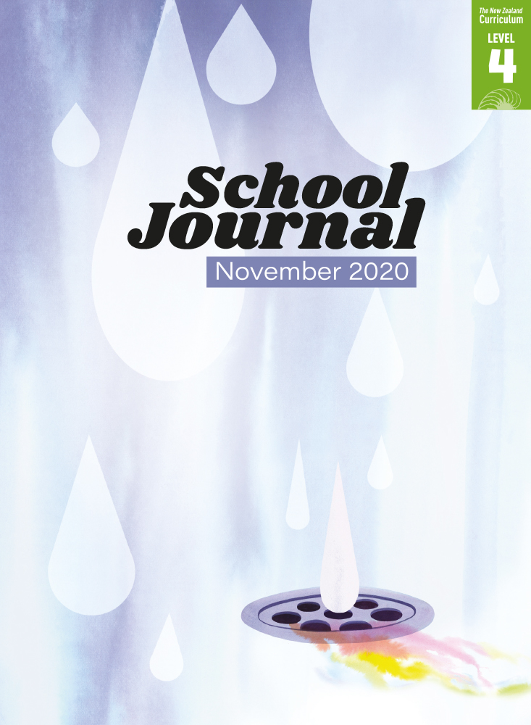

School Journal

Level 4, November 2020

**Year 7**

# Aunties

by Maria Samuela

The[Learning Progression Frameworks](https://curriculumprogresstools.education.govt.nz/lpf-tool/) describe significant signposts in reading and writing as students develop and apply their literacy knowledge and skills with increasing expertise from school entry to the end of year 10.

## Overview

Maria Samuela’s affecting story chronicles the week leading up to the narrator’s mother’s funeral, with all its sadness and confusion and overwhelming sense of loss. The story’s one light is the presence of the narrator’s extended family – and the sense that her many aunties will continue to be there in the future, providing the kind of support and love that usually comes from a mother. The text includes references to a girl’s first period.  
Note: Go to Health and Physical Education Online for resources that support [Sexuality education for curriculum levels 1­–4](https://health.tki.org.nz/Key-collections/Curriculum-in-action/Sexuality-education-for-curriculum-levels-1-4).   
A PDF of the text is available at [www.schooljournal.tki.org.nz](http://www.schooljournal.tki.org.nz)

## Themes

|  |  |  |  |
| --- | --- | --- | --- |
| * Loss and grief | * Puberty | * Ngutu‘are tangata (family) |  |

## Related texts

**“Māui”** SJ L3 May 2016 | **“Ancestors”** SJ L3 Aug 2018 | **“Whānau”** SJ L3 May 2019

## Strengthening reading behaviours (what to notice)

|  |  |
| --- | --- |
| Text structure and features | Requiring students to: |
| * Implied information or ideas *Aunty Api‘i and Aunty Akaiti are at the kitchen table, sheets of newspaper spread in front of them. They’re laughing and telling stories about Mum and the olden days.  I’m meant to be vacuuming, but the vacuum cleaner is kept in Mum and Dad’s room, and I haven’t been in there since Sunday night.* * Flashbacks or time shifts *I look up. My aunties aren’t there anymore; it’s just Mum and me. She’s smiling. She holds her hand high to show off a long, trailing piece of skin. Mine has snapped and dropped on the paper.* | * use the context, other information in the text, and prior knowledge to understand what isn’t being explicitly stated, for example, use the text reference that the narrator hasn’t been in her parents’ room since Sunday night to infer that was when her mother died      * use the clues in the story so far to confirm that the mother has died and to then infer that her prescence is imaginary. |

|  |  |
| --- | --- |
| Vocabulary | |
| Possibly challenging words | smothers, umu pit, ornaments, mantelpiece, rosary, geometric, intricate, crook, barely, bustling, kīkau, mainese, sanitary, pry, christened, bickering |

|  |
| --- |
| Helpful prior knowledge (pre-reading and introducing the text) |
| * Some understanding of loss and grief after the death of a loved one * Some knowledge of emotional and physical changes experienced in puberty * Understanding that some Pacific cultures have strong religious and family ties * Knowledge that death and funerals involve specific rituals. |

## Possible reading and writing purposes

* Find out how her aunties support the main character to deal with challenging situations
* Identify and think critically about how the writer portrays the characters authentically and realistically
* Analyse the language choices the author made and describe the impact on the reader.

See *Effective Literacy Practice in Years 5–8* for information about teaching comprehension strategies ([Teaching comprehension](https://literacyonline.tki.org.nz/Literacy-Online/Planning-for-my-students-needs/Effective-Literacy-Practice-Years-5-8/Teaching-comprehension))   
and for suggestions on using this text with your students ([Approaches to teaching reading](https://literacyonline.tki.org.nz/Literacy-Online/Planning-for-my-students-needs/Effective-Literacy-Practice-Years-5-8/Approaches-to-teaching-reading)).

## Possible curriculum contexts

This text has links to level 4 of *The New Zealand Curriculum* in: [**ENGLISH**](http://nzcurriculum.tki.org.nz/The-New-Zealand-Curriculum/English) [**HEALTH AND PHYSICAL EDUCATION**](https://nzcurriculum.tki.org.nz/The-New-Zealand-Curriculum/Health-and-physical-education)

## Understanding progress

The following aspects of progress are taken from the [Learning Progression Framework](https://curriculumprogresstools.education.govt.nz/lpf-tool/)s and relate to the specific learning tasks below. See the LPFs for more about how students develop expertise and make progress in these aspects:

* Reading for literary experience; Reading to organise ideas and information for learning
* Making sense of text: using a processing system; using knowledge of text structure and features; reading critically
* Creating texts for literary purposes.

## Strengthening understanding through reading and writing

**Select from the following suggestions and adapt them** according to your students’ strengths, needs, and experiences.   
Note: Most of these activities lend themselves to students working in pairs or small groups.

* Prompt the students to make connections. *Is there any part of the story you can relate to and would like to share? Has there been a a time when a family member has supported you or when your family has dealt with a challenging or unexpected situation? Has there been a time when you have had to deal with an unexpected or awkward situation?*
* Explain that the reader needs to infer what is happening from clues the writer provides. To help the students unpack the story, highlight some relevant quotes, for example, “The house is packed”, “She soaks the crook of my neck with her tears”, “I’m growing into a woman”, “I haven’t been in there since Sunday night”, “cardboard boxes from the florist fill the room”. Ask the students what they can infer about events from these quotes. *I think the author is trying to say …*
* Discuss how the story unfolds and ask the students what they thought of the mysterious way events were portrayed. Did they have an “Oh, yeah” moment when they realised that the characters were preparing for the mother’s funeral? Did they make predictions and then change those predictions as they read on? Pull out parts of the text and ask the students what they first thought was happening. What changed or confirmed their thinking? *On page 20, the narrator describes herself peeling the potatoes. When she looks up, her aunties are no longer there. What do you think the narrator wants us to think at this time? Why does the main character try to make her peelings as long as possible?*
* The story takes place over four days. Using the four headings for Monday to Thursday, have the students summarise what happens on each day. Add in two more headings, Before Monday and After Thursday, and ask them to note what they infer happened then (Mum dies before the story starts and the funeral takes place after the story ends). The students could create a timeline showing the order of events. (To support students to summarise, have them complete a 5Ws & H chart [who, what, when, where, why, how] after reading a section of text. They can then use their answers to write a twenty-word or less summary.)
* Support the students to identify and think critically about how the writer portrays the situation and characters. *Do you think this could have happened to the author? What makes it so real?* Have them jot down quotes from the text, including the dialogue, that makes the situation seem real and authentic and analyse the impact of the author’s particular language choices with each other.
* Have the students use the **Exploring the language** template at the end of this TSM to analyse the language used in the story. Ask them to choose some quotes that made the story seem particularly real and write those in the left-hand column. In the right-hand column ask them to write how they reacted when they read the quotes (How did they feel? What did it remind them of?).
* Discuss the way the author adds details that make the description of the characters and events very easy to visualise. Copy the first three paragraphs and use these as a mentor text. Have the students rework these to describe how their family greet and prepare for an occasion (not necessarily a funeral). Explain how when authors base their writing on things that have happened in their own family, it can help to make the events seem authentic. Share how the choice of words and the descriptions of the setting might change if someone from a different culture was writing about a similar event.

|  |
| --- |
| **“Aunties” Exploring the language** |

|  |  |
| --- | --- |
| Quote from the story | My reaction |
|  |  |
|  |  |
|  |  |

